# PROJECT REPORT TEMPLATE

**Title: Uncovering the Gaming Industry’s Hidden Gems: A Comprehensive Analysis of Video Game Sales**

**INTRODUCTION**

Video game sales analysis is the process of collecting and analysing data about the sales of video games in order to understand market trends and consumer behaviour. In 2019 the online gaming market in India was estimated at rupees 6200 crore with an estimated 300 million gamers, 41.6% increase from 2018. As of 2021, it is one of the top 5 mobile gaming markets in the world.

By the third quarter of 2020 there were more than 7.4 billion mobile game downloads. The industry is projected to reach 510 million gamers by 2022.

Unit sales for new games in 2022 increased by 16% compared to 2021, almost reaching 2019 levels.

The gaming industry supports a total economic including: $261.4 billion of output (business sales) 1.8 million jobs with $74.0 billion of labour income, $40.8 billion of federal, state and local taxes, including $10.7 billion of gaming taxes.

**PROBLEM DEFINITION AND DESIGN THINKING**

**EMPATHYMAP**

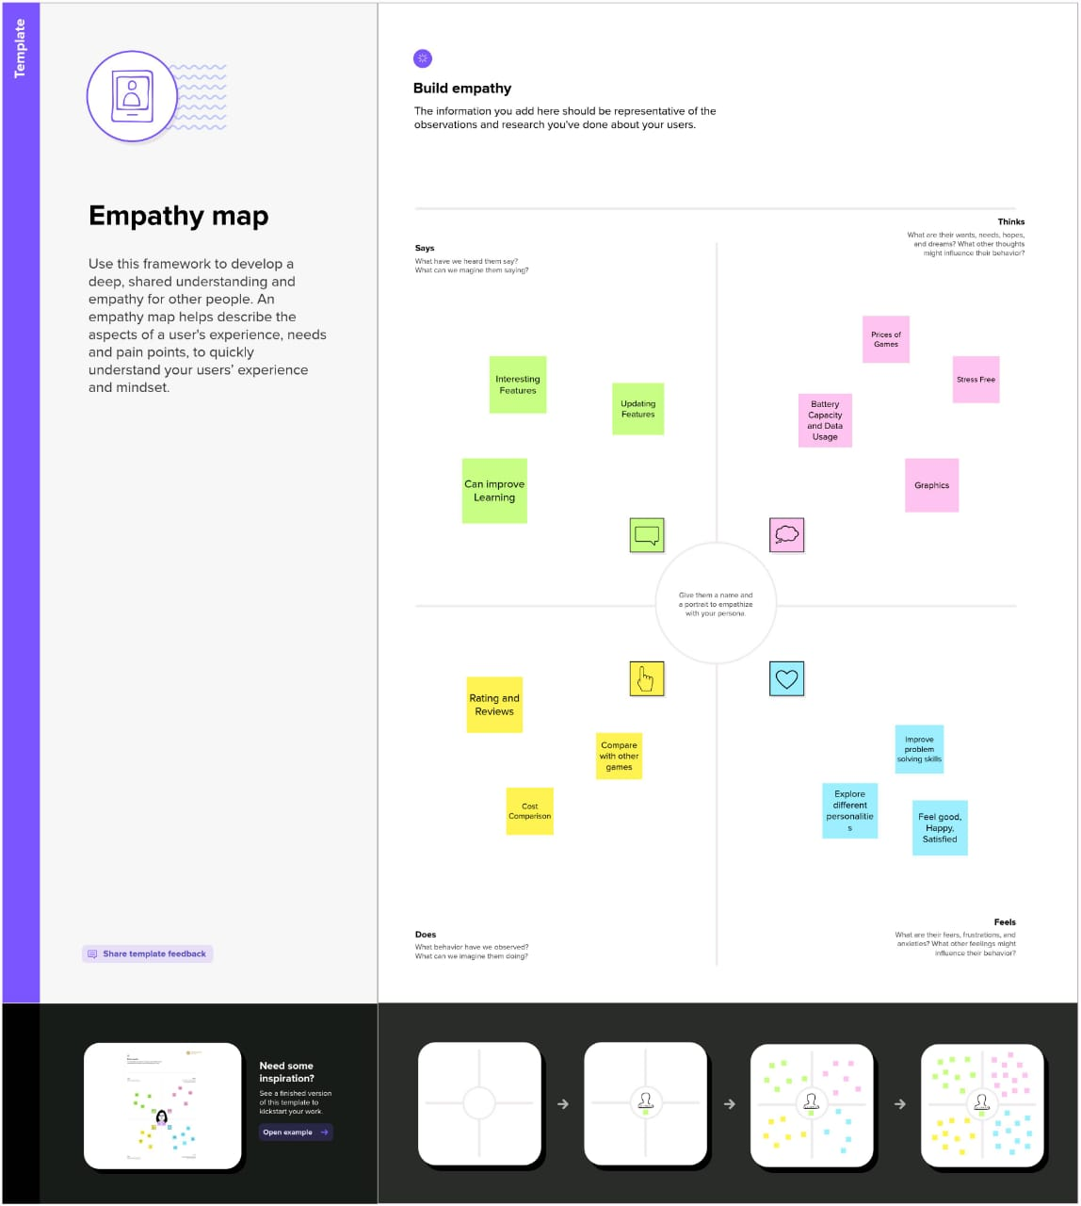

**BRAINSTORM AND IDEA PRIORITIZATION**

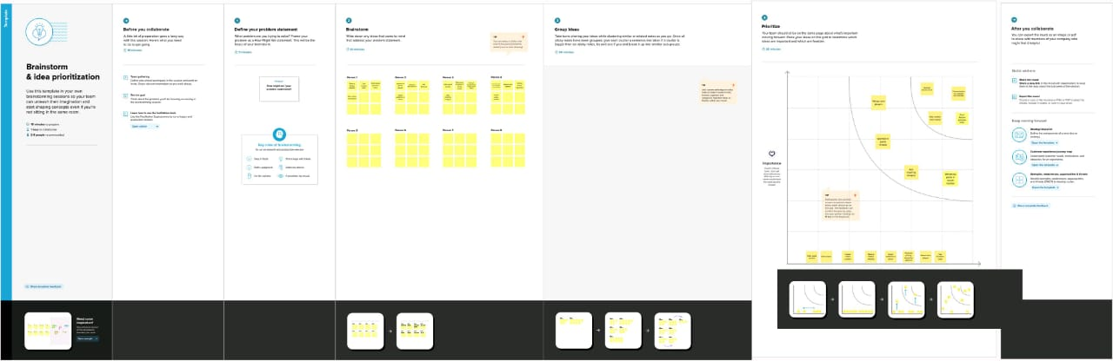

**RESULT**

1. Sales in different region analysis

2. Genre with rank analysis

3. Total sales analysis

4. Top 5 publishers analysis

5. Best 10 selling genres on platform analysis

6. Top 10 EU selling video games analysis

7. Top 10 JP selling video games analysis

8. Top 10 NA selling video games analysis

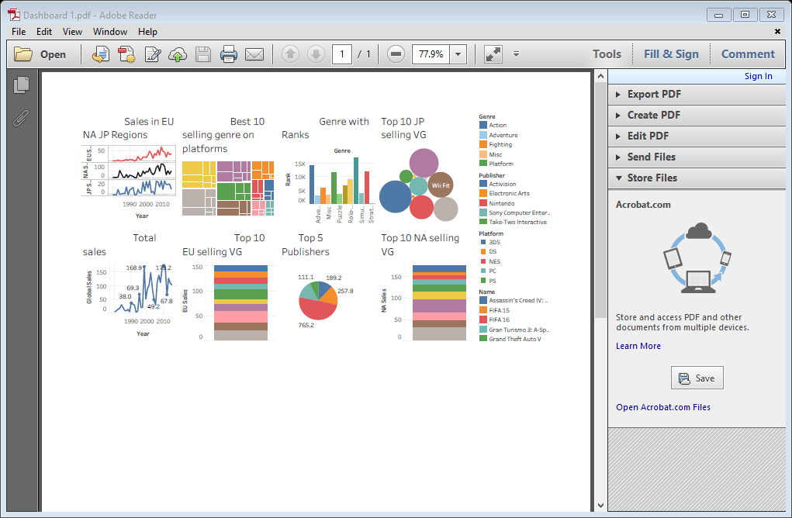

**ADVANTAGES AND DISADVANTAGES**

Since the time video games entered the entertainment industry, it becomes a necessary part of it and the most popular one. The video games sector is expanding and it covers a vast region.

Video games can be used to help improve test scores, teach life and job skills, improve brain function, and encourage physical exercise.

Gaming has also been associated with sleep deprivation, insomnia and circadian rhythm disorders, depression, aggression, and anxiety, though more studies are needed to establish the validity and the strength of these connections.

**APPLICATION**

As with other forms of media, video games have often been released in different world regions at different times. The practice has been used where localization is not done in parallel with the rest of development or where the game must be encoded differently, as in PAL vs. NTSC. It has also been used to provide price discrimination in different markets or to focus limited marketing resources. Developers may also stagger digital releases so as not to overwhelm the servers hosting the game.

**CONCLUSION**

By the above data we can say that action games on DC or PlayStation for that matter are the most popular and are the ones responsible for maximum sales all over the globe. Also as these games are so abundant and popular (ranking wise), variation in the sales of one or two such games would not cause significant change in the overall sales.

**FUTURE SCOPE**

Game Designing is one of the most upcoming Courses for students who wanted to make a Game Designer Career in India in animation. The gaming industry is rapidly growing at a pace of 50% per annum. There is a very wide and bright future in game design in India. Students can earn up to 3 Lakh to 5 Lakh PA.

In the year 2030, virtual reality and augmented reality will dominate the gaming industry. In addition to this, numerous gamers will significantly use this technology to introduce new genres to the audience.